**Count Leaves in Binary Tree:-**

Given a Binary Tree of size **N** , You have to count leaves in it. For example, there are two leaves in following tree

        1  
     /      \  
   10      39  
  /  
5

**Input:**  
First line of input contains the number of test cases **T**. For each test case, there will be only a **single** line of input which is a **string** representing the tree as described below:

1. The values in the string are in the order of **level order** traversal of the tree where, numbers denote node values, and a character “N” denotes **NULL** child.
2. For example:  
   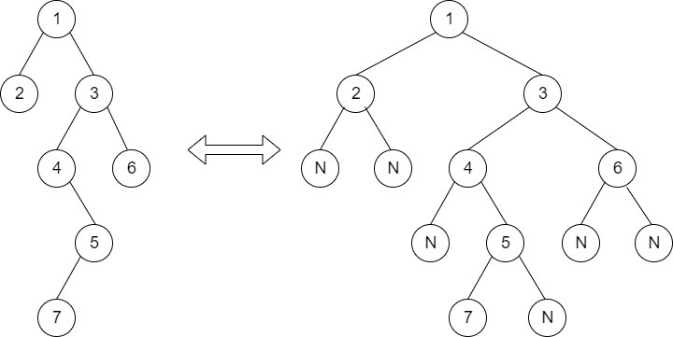  
   For the above tree, the string will be: 1 2 3 N N 4 6 N 5 N N 7 N

**Output:**  
For each test case print the count of leaves.  
**Your Task:**  
You don't have to take input. Complete the function **countLeaves()**that takes **root**node of given treeas parameter and **returns**the count of leaves in tree . The **printing**is done by the **driver**code.  
**Constraints:**  
1<= T <= 30  
1<= N <= 104  
**Example:  
Input:**  
2  
3 4 2   
4 8 10 7 N 5 1 3   
**Output:**  
2  
3  
**Explanation:**  
Test Case 2:  Given Tree is   
                                 4  
                               /     \  
                            8       10  
                          /          /      \  
                       7          5        1  
                      /  
                     3  
Three leaves are 3 , 5 and 1.